WORK ORDER NO: | Not Applicable
Change Control No | CR-IHP-2025-16 Digital Signing Prescription v2

System: VESALIUS.geo  Change Classification: CR  Assessed By: NOVA Product Team  Designation: | Sub-system: CMS, PHM, Interface  Signature:  Date: 15 September 2025
Assumptions & Pre-requisites (if any):
- Price stated is exclusive of all taxes

COST OF CHANGE
No | Activity | Rate  (RM/ M-Day) | Effort  (M-day) | Cost  (RM)
 | Customer Requests (as in the CR-Part1):  Refer to CR-Part1 with the same reference number from the customer | Please refer to the Quotation | Please refer to the Quotation | Please refer to the Quotation
 | VESALIUS Standard Integration Framework (SIF)  Annual Support & Maintenance Fees |  | 1
 | Iguana HL7 License (per Channel)  Annual Support & Maintenance Fees |  | 4
NOVA’s response:
- Please refer to “Statement of Work” in this document for the scope of changes and layout.

- EDD will be advised later.

- Additional changes or enhancement from the agreed scope in “Statement of Work” is subjected to separate charges.

- Mock screens and mock system printout are not drawn to scale, final screen and printout may differ from the mock up.

 | Total

Terms of payment | Follow project agreement
Warranty | Follow project agreement

Please note that this CR Part 2 is valid for a period of one month from the date of this work order.

Price quoted is exclusive of all applicable taxes payable.
Statement of Work (SOW)

Introduction
Malaysia’s Ministry Of Health (MOH) has been exploring electronic medical certificates and prescriptions as part of health care digitalisation. All medication requires a valid prescription certified by an MMC-registered physician in order to be dispensed. A valid prescription shall include the signature, address & dated by prescriber, name, identification number & address of the patient, the dose, quantity & instruction of taking medication, as mandated by the Laws of Malaysia Poison Act 1952 Regulation 21, 2006. Examples of Group B Medications: Atorvastatin, Amlodipine, Sildenafil

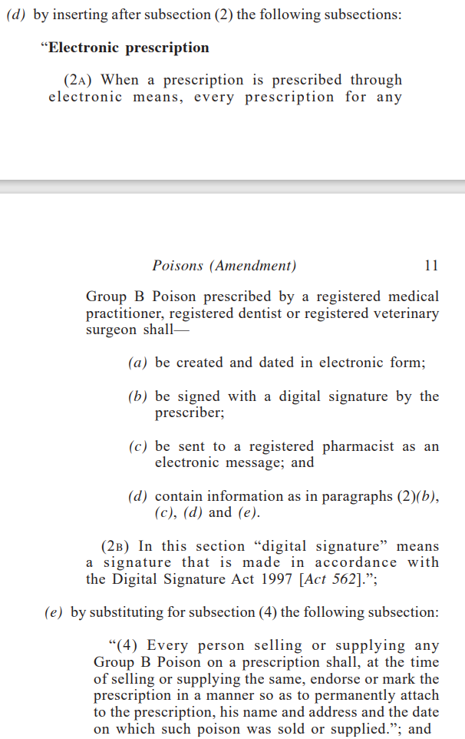

Respective hospital required to provide the digital certificate as the identity of the issuer issuing the electronic prescription.

Issuer’s Digital Signature is mandatory field with base64 format when submit electronic prescription to the Government Authorities. An electronic signature to ensure integrity and non-repudiation of documents. The e-prescription shall be signed using issuer’s digital certificate. In the event where hospital utilise the services from authorised service provider, the e-prescription shall be signed using service provider’s digital certificate.

Objective
To comply with Malaysia’s Pharmacy Poisons Act 2022 and Digital Signature Act 1997 to authenticate prescriptions.

Pre-requisite
      - Doctor prescribe medication in VESALIUS as per current workflow.
      - All Doctors must have the certificate code issued by PosDigiCert and store in VESALIUS before the Doctor able to do the signing process.
      - VESALIUS do not store the digital certificate. VESALIUS only store the Certificate Request Code which is the code or digital identity created at PosDigiCert for computing easy access. To maintaining high level of security, the digital certificate is not able to download to your computer or mobile devices. It contains a bundle of doctor’s private key and hospital’s public certificates which are secured by a trusted Certification Authority like PosDigicert.
      - All pre-requisite data as below must exist or defined in the system:
- Doctor’s Identification Number
- Doctor’s Full Name as per MyKad/Passport information
- Doctor’s Supporting Document in PDF softcopy (Letter of Authorisation and scanned NRIC)
- Doctor’s PIN
- Doctor’s certificate code and related information
      - This CR will split to multiple releases due to IH’s request to meet the go-live timeline.
- Phase 1
- Remaining enhancement

Scope of Changes

Data Migration into VESALIUS Database
  - To perform one-time data loading into VESALIUS Database.
  - New Data Template creation required for this CR
- Doctor Certificate Template
  - PDF soft-copy required for each doctor in this data migration:
- Doctor’s Letter of Authorisation (LOA) in PDF file format
- Doctor’s scanned NRIC in PDF file format
  - Each PDF soft-copy has to be unique and tagged to each doctor. The file format will be advised later when close to data migration activities.
  - This data loading is to define all the required data belongs to each doctor for the Digital signing request to PosDigiCert.
  - IH user need to request the doctor’s certificate data manually with PosDigiCert to provide the details in the date template Excel file with the PDF soft-copy files belongs to each doctor to NOVA for data migration purposes.
  - Customer must provide the Data Templates in one effort and NOT in multiple batches submission, and ensure the data has been checked to eliminate any obvious error.
  - The single-submission of CLEAN data template will be check and load for both UAT and PROD Onsite data migration.
  - NOVA to perform any pre-data loading checking and verification on the data submitted before and after loading for both VESALIUS UAT and PROD Database.
  - To perform data loading based on Data Template into VESALIUS UAT and PROD Database, one time only.
  - To perform random verification through VESALIUS.geo on the new data loaded.
  - Any new or changes of master data after data migration exercise is not within the scope of this document. Please inform NOVA support team on your request.
  - With the Data Migration in place, there will be no GUI or maintenance function in VESALIUS.
  - VESALIUS will retrieve from the backend table to generate an outgoing event for interface.
  - IH to arrange data upload to PosDigiCert (outside VESALIUS scope). If they have UAT env, both UAT and PROD.
  - IH to provide the sample of signed PDF with embedded digital signature for testing to ensure the signed PDF from incoming message able to open and view the document’s signature properties.

Enhancement to VESALIUS – Revoke Reason Maintenance
  - Introduce new Maintenance to define the list of Revocation reason with its description
- Reason Code
- Reason Description
  - This reason list will be listed at the new function when user request for revocation from VESALIUS to external system.

Enhancement to VESALIUS – New function to upload required documents for Request/ Revoke DigiCert
  - Introduce new function to allow user to upload the supporting document(s) for each doctor.
  - This function will display the certificate code and information with the validity period for user references.
Field | Description
Name | - Doctor’s Full Name (First Name + Middle Name + Last Name) without Salutation/Title as per Employee Profile
MCR Number | MCR Number
Document Number | - Doctor’s Identification Number as per Employee Profile – Personal Document  - Retrieve the Document Number of the Document Type as per System Setting – “PATIENT_PRINT_DOC_TYPE”
Certificate Request Code | - MYCRS unique request code for each validity period  - This code will be use in revocation request
Certificate | - Mapped to “CertinBased64” Certificate information responded from MyCRS
Certificate Status | - 0 - PROCESSING, 1-ACTIVE, 2 - REVOKED, 3 – EXPIRED, 4 – INACTIVE and 5-CLOSED
Valid From | - Date of certificate issuance  - Format is yyyy-mm-dd hh:mm:ss
Valid To | - Date of certificate issuance + 365 days  - Format is yyyy-mm-dd hh:mm:ss
Certificate request by | - The latest username who requests from VESALIUS
Certificate request date time | - The latest date and time of the user who request from VESALIUS
Certificate Pin | - Certificate Password Pin generated by VESALIUS  - PIN length must be 8-16 alphanumeric character, at least 1 capital letter, at least 1 small letter, at least 1 number and at least 1 symbol
Certificate Pin by | - The latest username who reset the pin from VESALIUS
Certificate Pin date time | - The latest date and time of the user who reset the pin from VESALIUS

  - There will be a section to allow user to upload and view the following supporting document belongs to the doctor:
- Doctor’s Identification document in PDF copy (scanned copy of IC front & back for Malaysian / Passport for Non-Malaysian)
- Letter of Authorisation to request – Doctor’s signed consent document in PDF copy
- Letter of Authorisation to revocate – Doctor’s signed consent document in PDF copy
  - System will display the latest username and latest uploaded date time for each successful uploaded document.
  - There should be always one (1) document uploaded for each document type.
  - Uploaded documents are required as supporting document upon request for new or renewal of certificate code issuance from VESALIUS to external system.
  - This function allows to view the active and past inactive certificate code information.
  - At any point of time, there should be only 1 valid/active certificate code issuance for each doctor. There will be no duplication of certificate code for each doctor.
  - User can request certificate code issuance and revocation many times and system need to keep track on the number of requests with the requesting user and date and time of each request.

Enhancement to VESALIUS – New function for Reset Pin, Request and Revoke DigiCert
  - Introduce a new function will list all active HCPs – Doctors available in the system
  - This function will list all certificate code request information as below:
Field | Description
PRN | Employee Profile – Doctor PRN
Name | - Doctor’s Full Name (First Name + Middle Name + Last Name) without Salutation/Title as per Employee Profile
MCR Number | MCR Number
Document Number | - Doctor’s Identification Number as per Employee Profile – Personal Document  - Retrieve the Document Number of the Document Type as per System Setting – “PATIENT_PRINT_DOC_TYPE”
Certificate Code | - MYCRS unique request code for each validity period
Validity From | Date of certificate issuance
Validity To | Date of certificate issuance + 365 days
Consent LOA Flag | - Tick as indicator that this supporting document file is uploaded  - Blank if there’s no document uploaded.
NRIC Flag | - Tick as indicator that this supporting document file is uploaded  - Blank if there’s no document uploaded.
PIN Flag | - Tick as indicator that there’s Certificate Password Pin value  - Blank if there’s no value
Revoke LOA Flag | - Tick as indicator that this supporting document file is uploaded  - Blank if there’s no document uploaded.

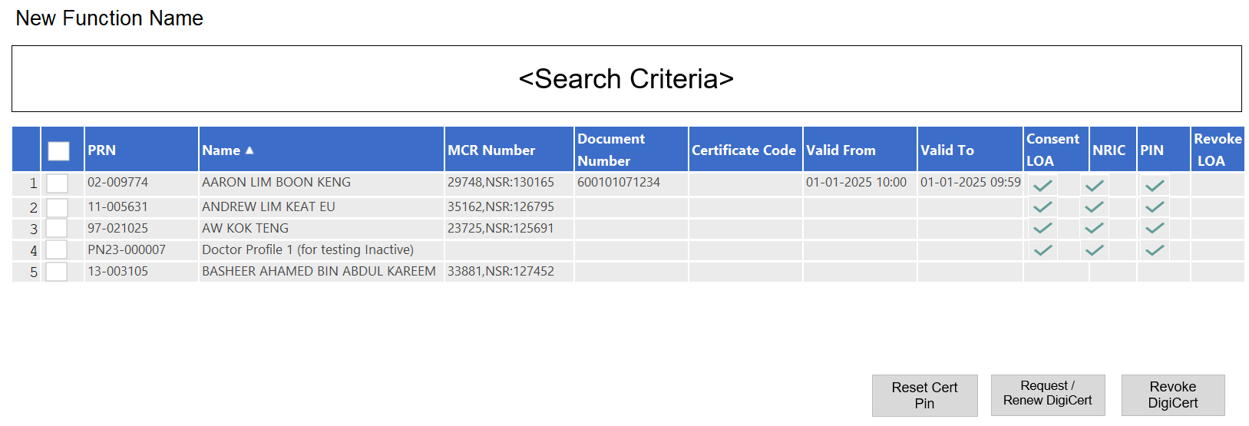

  - There will be a checkbox at the 1st column with the “Select All” option at the header for user selection. By default, the “Select All” option will be selected.
  - This function allows the user to select 1 or multiple doctor(s) to process.
  - VESALIUS requires to request the certificate code issuance to MyCRS via API for all doctors that require to sign on the prescription.
  - VESALIUS requires to send the Revocation request to MyCRS API for the doctor whom resigned from the hospital
  - For every change/reset of pin, VESALIUS need to sync with MyCRS via API for the PDF signing to be successful.
  - There will be three (3) buttons to process the selected doctor in this list:
  - To reset Certificate Password Pin
  - To submit new/renewal request for certificate code issuance
  - To submit revocation request of certificate code issuance
  - Reset Certificate Password Pin
- The 1st time password is uploaded from the data migration process.
- Subsequently, VESALIUS need to generate and store the Certificate Password Pin
- Certificate Password Pin must consist the following requirements:
    - Length must be 8-16 alphanumeric character
    - At least 1 capital letter
    - At least 1 small letter
    - At least 1 number
    - At least 1 symbol
- When user click at this button, system will generate the new Certificate Password Pin and triggers the outgoing event for interface to external system.
  - New or Renewal request for certificate code issuance
- As some information are maintained at Employee Profile function and some information in the new function mentioned above, user need to ensure all the mandatory fields are entered before submit request for certificate issuance.
- The user must make sure Doctor’s Identification No., Name, Hospital Name and Hospital Registration No. remains as per certificate code issuance.
- The certificate validity is starting from the date of certificate issuance (date from) and will be valid for 1 year from that date.
- Information required for certificate code issuance request and revocation will further explain at the interface section.
- Before the expiry of the certificate, the user can request for renewal of certificate by individual or batch for all doctors regardless when is the expiry date.
- For an example,
    - During the pre-go live, the user has requested for certificate code issuance for all doctors on 25th December 2025.
    - Hence, all successful certificate issuance will be valid from 25th December 2025 to 24th December 2026.
    - There are 2 new doctors joined the hospital from 1st April 2026 and successful certificate issues for the 2 new doctors are valid from 1st April 2026 to 31st March 2027.
    - When user triggers for renewal by batch on 15th December 2026, all doctors certificate issuance will be renewed. Although the 2 new doctors joined later with later expiry date, their certificate issuance will be renewed and has the same validity as other doctors.
  - If user request revocation, the following fields/information is mandatory
- Reason of revocation – drop down list from Revoke Reason maintenance
- Authorized Letter – uploaded by user
- Remarks – this is mandatory
  - Required fields to request/renew and revocation of digital certification issuance will further explain under the Interface section below.

Enhancement for reset pin, request and revoke certificate code information

Build both Outgoing and Incoming interface schema with new asynchronous events as per below in related to Doctor’s certificate code information.
- Reset Certificate Pin
- Request/Renewal of certificate code
- Revocation of certificate code

Reset Certificate Pin
- Outgoing Schema – The following information to reset pin:
Field | Mapping fields | Sample Data
Doctor Information
Doctor Name | Doctor’s Full Name (First Name + Middle Name + Last Name) without Salutation/Title as per Employee Profile | Doctor NOVA
Doctor NRIC | - Doctor’s Identification Number as per Employee Profile – Personal Document  - Retrieve the Document Number of the Document Type as per System Setting – “PATIENT_PRINT_DOC_TYPE” | 600101071234
Current Certificate PIN | - Certificate password.  - PIN length must be 8 - 16 alphanumeric character, at least 1 capital letter, at least 1 small letter, at least 1 number and at least 1 symbol | Nova@123
New Certificate PIN | - Certificate password.  - PIN length must be 8 - 16 alphanumeric character, at least 1 capital letter, at least 1 small letter, at least 1 number and at least 1 symbol | Nova@123@

- Incoming Schema
- If there is valid error responded from the API, the rest of the incoming field will be blank/null except the status column. VESALIUS need to display the latest request with the error message for user to rectify and re-request again.
- The Incoming message will include the following information to store in VESALIUS
Name | Data Type | External API Description | Sample Data
Pin Reset Code | String (20) | Reset PIN activation code.
Pin Reset Status Code | String (4) | Reset Status Code | 9012
Pin Reset Status Message | String (100) | Reset Status Message | PIN length must be 8-16 alphanumeric character

Request New/Renewal of certificate code
- Outgoing Schema – The following information are needed to request or renewal of the certificate code issuance:
Field | Mapping fields | Sample Data
Doctor Information
MCR Number | MCR Number of the Ordering Doctor | 12345,NSR:123456
Doctor Name | - Employee Profile – Doctor’s Full Name (First Name + Middle Name + Last Name) as per IC or Passport without Salutation/Title  - This is mandatory field | Doctor NOVA
Doctor NRIC | - Doctor’s Identification Number as per IC or Passport  - Employee Profile – Personal Document  - Retrieve the Document Number of the Document Type as per System Setting – “PATIENT_PRINT_DOC_TYPE”  - This is mandatory field | 600101071234
Doctor DOB | - Doctor DOB  - Format is DD-MMM-YYYY | 01-Jan-1960
Doctor Address 1 | - Employee Profile – Doctor Address 1  - Value of Address Type = “HOME”  - This is mandatory field | UNIT 10-01, LEVEL 10, AVENUE COVE CONDOMINIUM, JALAN KENANGA 8/18,
Doctor Address 2 | - Employee Profile – Doctor Address 2  - Value of Address Type = “HOME” | TAMAN PINANG, TANJUNG TOKONG
Doctor Address 3 | - Employee Profile – Doctor Address 3  - Value of Address Type = “HOME” | GEORGETOWN
Doctor Address Postal | - Employee Profile – Doctor Address 5  - Value of Address Type = “HOME” | 10070
Doctor Address State | - Employee Profile – Doctor Address 4  - Value of Address Type = “HOME” | Pulau Pinang
Doctor Address Country Code | - Employee Profile – Doctor Address Country Code  - Value of Address Type = “HOME” | MY
Doctor Address Country Description | - Employee Profile – Doctor Address Country Description  - Value of Address Type = “HOME” | Malaysia
Doctor Home No | - Employee Profile - Doctor Contact  - Value of Contact Type = “HOME_PHONE” | +60412345678
Doctor Mobile No | - Employee Profile - Doctor Contact  - Value of Contact Type = “MOBILE_PHONE” | +60121234567
Doctor Fax No | - Employee Profile - Doctor Contact  - Value of Contact Type = “OFFICE_PHONE” | 042383211
Email Address | - Employee Profile – Doctor’s Email Address  - Value of Contact Type = “Email”  - This is mandatory field | digicert@islandhospital.com
Nationality Code | - Employee Profile – Doctor’s Nationality  - This is mandatory field | MY
Certificate PIN | - Certificate password.  - PIN length must be 8 - 16 alphanumeric character, at least 1 capital letter, at least 1 small letter, at least 1 number and at least 1 symbol  - This is mandatory field | Nova@123
Hospital Information
Company Code | Organisation – Hospital Code | IHP
Company Name | Organisation – Hospital Name | Island Hospital Sdn Bhd
Company Registration Number | Organisation – SST No | A01-2345-67891012
Company Tel No | Organisation – Phone No | +604-238 3388
Company Fax No | Organisation – Fax No | +604-238 3425
Company Address 1 | Organisation – Address 1 | 308,
Company Address 2 | Organisation – Address 2 | Jalan Macalister,
Company Address 3 | Organisation – Address 3 | George Town
Company Address Postal | Organisation – Address 5 | 10450
Company Address State | Organisation – Address 4 | Pulau Pinang
Company Address Country | Organisation – Country Description | Malaysia
Doctor Supporting Document
Document 1 Type | Document Type = NRIC | NRIC
Document 1 Format | Document Format = PDF or JPEG | PDF
Document 1 base64 | PDF Document 1 in base64 format | Uploaded NRIC PDF in base64 format
Document 2 Type | Document Type = LOA | LOA
Document 2 Format | Document Format = PDF or JPEG | PDF
Document 2 base64 | PDF Document 2 in base64 format | Uploaded LOA for Request PDF in base64 format

- Incoming Schema
- There should be only one (1) successful processed incoming certificate code information for the same Certificate Request Code. Subsequent incoming message of the same Certificate Request Code will be rejected by the system.
- When process the incoming certificate code, system will update the Validity To of the previous certificate information, if any with the Validity From – 1 day of the new certificate information.
- If there is valid error responded from the API, the rest of the incoming field will be blank/null except the status column. VESALIUS need to display the latest request with the error message for user to rectify and re-request again.
- The Incoming message will include the following information to store in VESALIUS
Name | Data Type | External API Description | Sample Data
Certificate Request Code | String (50) | MYCRS unique request code. Please keep this value for reference. Use in revocation request
Certificate Status Code | String (4) | Certificate Status Code | 9003
Certificate Status Message | String (100) | Certificate Status Message | Incomplete Parameter: Supporting document NULL
Certificate |  | Certificate details for information only  - Root = Root CA certificate  - Certificate = Signer / User certificate  - Intermediate = Intermediate CA certificate | { "root": "MIIJpDCCBYygAwIBAgIQSmYDwi", "certificate": "MIIFyTCCA7GgAwIBAgI", "intermediate": "MIIICjCCA/KgAwIBAg", "certificate": "MIIFyTCCA7GgAwIBAgIQW0ysoa", "statusCode": "901" }
Valid From | String (30) | - Date of certificate issuance  - Format is yyyy-mm-dd hh:mm:ss | 2021-02-05 14:30:43
Valid To | String (30) | - Date of certificate issuance + 365 days  - Format is yyyy-mm-dd hh:mm:ss | 2021-02-05 14:30:43

Revocation of certificate code
- Outgoing Schema – The following information to request revocation of certificate code:
Field | Type | Len | External API Description | Sample Data
Doctor Information
Certificate Request Code |  |  | - MYCRS unique request code.  - MYCRS Request code from  EnrollRoamingCert API
Reason Code | String | 16 | - Available values are [1, 5, -2]  - User selection when request revocation | -2
Reason Description | String | 20 | - Description of the user selected reason  - 1: KEY_COMPROMISED (Compromised)  - 5: CESSATION_OF_OPERATION (Termination)  - -2: NO_REASON_CODE (Other) | NO_REASON_CODE (Other)
Reason Remarks | String | 20 | Reason remarks entered by user | Doctor resign from hospital
Doctor Supporting Document
Document 3 Type |  |  | Document Type = Revoke | Revoke
Document 3 Format |  |  | Document Format = PDF or JPEG | PDF
Document 3 base64 |  |  | PDF Document 3 in base64 format | Uploaded LOA for Revoke PDF in base64 format

- Incoming Schema
  - If there is valid error responded from the API, the rest of the incoming field will be blank/null except the status column. VESALIUS need to display the latest request with the error message for user to rectify and re-request again.
  - The Incoming message will include the following information to store in VESALIUS
Name | Data Type | External API Description | Sample Data
Pin Reset Status Code | String (4) | Reset Status Message | 9030
Pin Reset Status Message | String (100) | Reset Status Message | Please revoke by using this Request Code: {LatestRequestCode} instead
  - User need to reprocess from the Monitoring function if incoming message has any error / fails.

Enhancement for Prescription Digital Signing

Build both new outgoing and incoming schema with the new asynchronous events to store and link the respective Prescription Script Number with Doctor’s certificate code information.
- Send prescription in PDF for digital signing
- Receive signed prescription PDF

Outgoing – Send prescription in PDF
- The purpose of this new event is to submit Outpatient Rx and Discharge Rx prescription for digital signing.
- Doctor and nurses will order Rx as per current workflow.
- Pharmacy will verify and/or intervene doctor’s order as per current workflow.
- The logic in processing the outgoing message:
- One (1) doctor will have one (1) Prescription Script Number in one visit.
- One (1) event belongs to one (1) Prescription Script Number.
- If patient is registered with multiple doctors on the same visit and each doctor ordered some medication for the patient, there will be multiple prescription script number generated. Each prescription script number will have its own printout and will be interface for digital signing.
- All Rx ordered of the patient, regardless of the dispense location, will be interfaced for digital signing. There will be no selective option on which item to interface and not interface.
- This logic applies to the following functions:
  - OP Pharmacy – Order Entry
  - OP Pharmacy – Outpatient Search
  - OP Pharmacy – Discharge Rx
- This new event is to interface the prescription in PDF base64 format to external system. Other Pharmacy printout is not within the scope of this SOW.
- When Pharmacy user pick up the patient’s record at the above-mentioned functions, system create the new workflow for system to generate the outgoing messages based on the available Rx order at this trigger point.
- System will check each prescription whether it has sent for digital signing.
- If it’s not sent for the 1st time, system will generate the outgoing event by prescription number in PDF for digital signing.
- Subsequent number of times the user picks up the same prescription number at the same and/or different pharmacy location, system will not interface or submits for digital signing.
- Any changes or additional order to the same prescription will not be interfaced / submitted for digital signing.
- Interface event for prescription signing is independently process. The Pharmacy users able to proceed to verify and process Doctor Rx orders as per current workflow.
- Rx order created and/or intervened by Pharmacy users will not be interfaced.
- Once the Pharmacy users finalised the order at above-mentioned function, the Pharmacy printout generated, which is the unsigned copy remains unchanged. User required to access to OP Pharmacy – View Rx History to view the signed prescription PDF, if any.
- If the doctor orders some normal OP Rx and External Rx, system will generate two (2) different prescription number and base on logic above to generate the two (2) different outgoing events.
- If the patient only has External Rx order, patient will not be listed at OP Pharmacy – Order Entry Rx and the “View Rx History” function as there is no medication to be verified and dispense by Pharmacist. Hence, system not able to interface this External Rx for prescription signing.
- The prescription sent for signing and the signed prescription content might not be tally with the list of prescription in VESALIUS as there might be changes after submit the prescription for signing.
- Due to the high possibilities of Rx order changes at this trigger point, the signed prescription in PDF might not tally with the medication that finalised by Pharmacist and/or given to the patient. This is out of VESALIUS system and will be managed by hospital SOP with users.
- Patient registered as Pharmacy External Visit will not appear at Doctor’s homepage. These external visit patients records will directly appear at OP Pharmacy – Order Entry without any doctor’s Rx order. Thus, External visit’s order will not be interface for prescription signing.
- The following information to submit Prescription for signing:
Field | Mapping fields | Sample Data
Doctor Information
MCR Number | MCR Number of the Ordering Doctor | 12345,NSR:123456
Doctor Name | Doctor’s Full Name (First Name + Middle Name + Last Name) without Salutation/Title as per Employee Profile | Doctor NOVA
Doctor NRIC | - Doctor’s Identification Number as per Employee Profile – Personal Document  - Retrieve the Document Number of the Document Type as per System Setting – “PATIENT_PRINT_DOC_TYPE” | 600101071234
Certificate Password PIN | - Certificate password.  - PIN length must be 8 - 16 alphanumeric character, at least 1 capital letter, at least 1 small letter, at least 1 number and at least 1 symbol | Nova@123
Hospital Information
Company Code | Organisation – Hospital Code | IHP
Company Name | Organisation – Hospital Name | Island Hospital Sdn Bhd
Company Registration Number | Organisation – SST No | A01-2345-67891012
Prescription Information
Visit Number | Patient Visit Number | OP25-0224628
Script No | Prescription generated by Ordering Doctor | 25-121449
Script Creation Date Time | - Creation Date Time of prescription  - Format in dd-mmm-yyyy hh24:mm:ss | 28-Aug-2025 08:35:00
Prescription Document | Finalized prescription PDF in base64 format

Incoming – Receive signed prescription
- The Incoming message will include the following information to store in VESALIUS
Field | Type | Len | Source of data | Sample Data
Digital Signed ID | String | 10 | Transaction ID assigned by DSS
Signed Date Time | Date Time |  | Date time when the signed PDF received
Digital signed PDF |  |  | Digital signed PDF in base64 format

- Patient Visit Number and Prescription Number is the unique identifier and must exist or match in system. Any incoming message with incorrect patient visit number or prescription number will be rejected by the system.
- There should be only one (1) successful processed incoming signed PDF for each prescription number. Subsequent incoming signed PDF will be rejected by the system.
- User need to reprocess from the Monitoring function if incoming message has any error / fails.

Enhancement to Pharmacy – OP Rx History
  - Able to view the signed PDF from the Application as it is using the browser setting. User need to use the print function at the browser for printing purposes, if necessary.
  - Able to download the signed PDF from the Application for user verification to ensure it’s signed by the authorised parties.
  - There is no change to OP and Discharge Rx prescription printout.

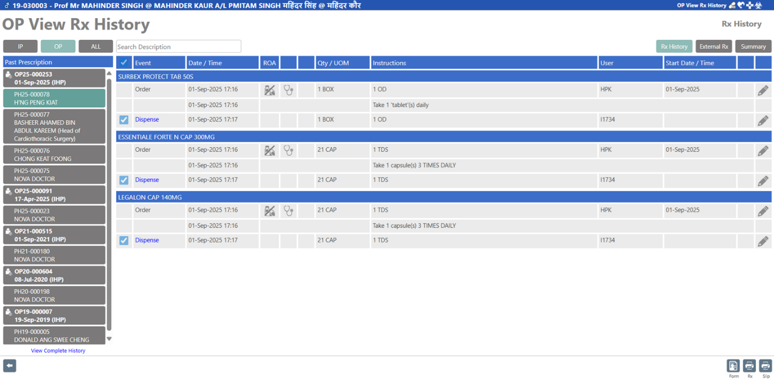
New icon to view the signed PDF

Enhancement to EMR – Visit View
  - Introduce new section to view the list of signed prescription in PDF
  - Able to view the signed PDF from the Application as it is using the browser setting. User need to use the print function at the browser for printing purposes, if necessary.
  - Able to download the signed PDF from the Application for user verification to ensure it’s signed by the authorised parties.
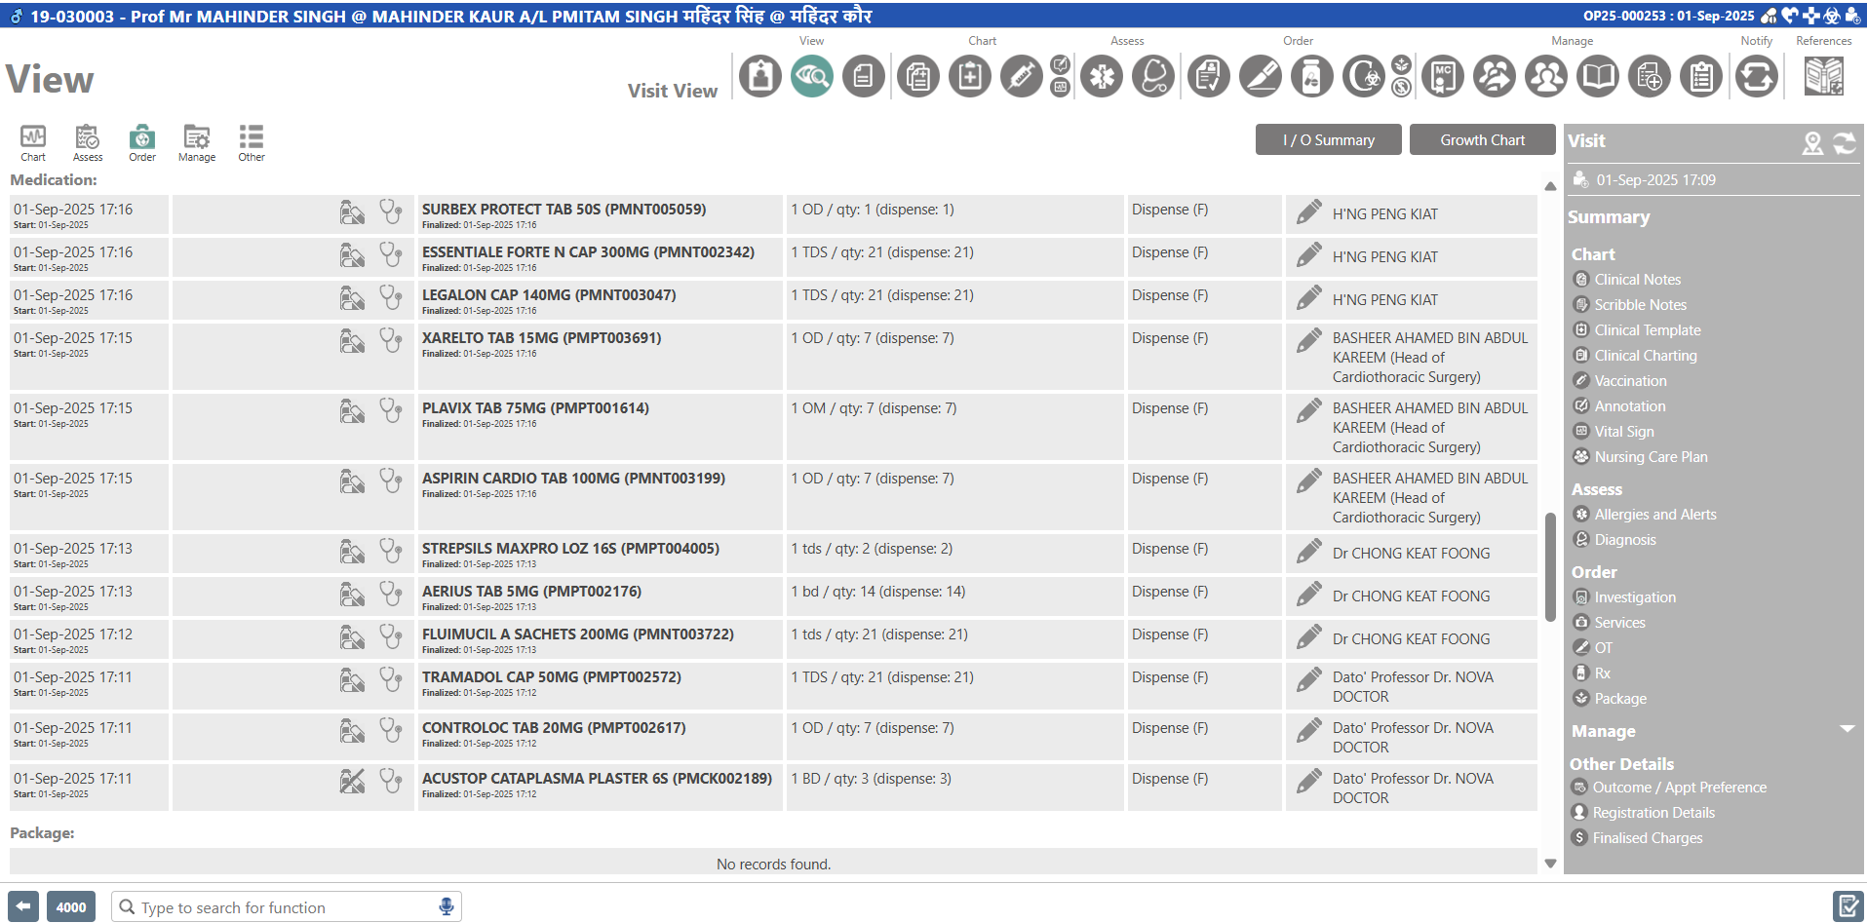
New icon to view the signed PDF, if any

There’s no enhancement for Report Schema

Changes to OP Prescription/Discharge Rx/External Rx printout
  - Adjust the footer of the printout to have higher footer size to accommodate the Digital signing position on the signed PDF
  - The placement of the digital signing position will be located below Prescriber Date Time at the footer. This digital signing spacing will combine two (2) lines as the X and Y coordination.
  - There will be no logic of page count on each PDF send for digital signing. Hence, the digital signing information will be signed at Page One (1) only regardless the actual number of pages on each PDF document. Other pages will have empty spacing at this position of the footer on the signed prescription PDF.
  - Due to the space limitation and the digital signing is from external parties, there might be some overlapping of text wording which is beyond of VESALIUS control.
Note: Hospital requires to raise a separate Change Request (CR) with the detailed requirements for any changes to the OP prescription printout.
  - Due to the additional lines added for digital signing information, the footer section will be allocated more/higher and this causes the available spacing for the content details will be reduced.
  - There’s no change to the existing logic and content information.

Changes Descriptions:
Field Name | Description | Changes Required
Footer Section
Digital Signing Position | Information will be filled from the Digital signing | - New Information  - Add 2 row at the position below the Prescribe date & time line.  - The same footer will apply to all pages.  - Signer XY coordination of XStart, XEnd, YStart and YEnd will be determined during development  - Signer XY coordinate in “Pixel” will be converted from “CM” measuring from left-top and right-top corner of the standard A4 paper size.  - Please refer to the mock-up sample for the details.

Mock-up Sample – Other Pages except for first page:
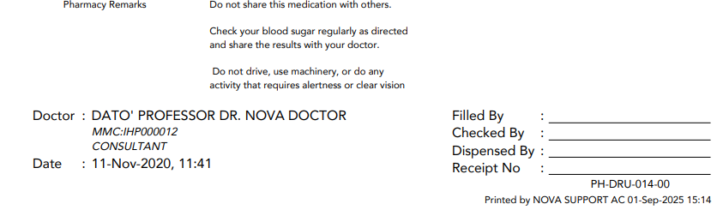

Mock-up Sample – First page only:
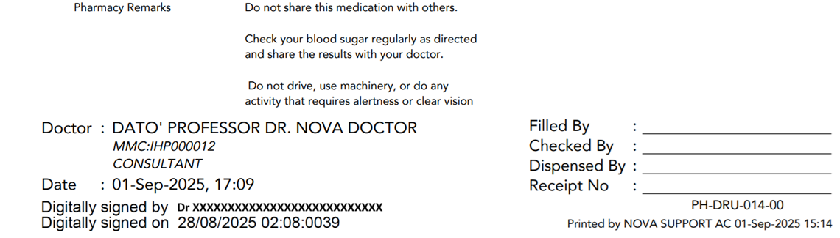

Iguana Interface with PosDigiCert API

PosDigiCert API – Parameter for Environment access to be provided by the Hospital
  - Both UAT and PROD URL Path to access to PosDigiCert API will be provided by the Hospital
  - SFTP information to be provided by IHH
  - The path of the designated folder in IHH server to be provided by IHH.
  - Both UAT and PROD Credentials information such as API Username, Password, Domain and etc to be provided by IHH
  - Hospital’s Issuer Digital Signature and Client ID to be provided by IHH

Reset Certificate Pin

Build new scripts to process the new outgoing events to reset Certificate Pin.

GenerateResetPinCode – First API to get activation code for reset roaming certificate PIN / password
- Request Parameter
Field | Type | Len | External API Description | Mapping Fields | Sample Data
projectCodesetProfile | String | 50 | - Mandatory.  - MYCRS project code.  - IHP to provided once provisioned by MYCRS.  - Value for Staging and Production is different | This will be hardcoded at Iguana | IHP to provide
userId | String | 15 | - Mandatory.  - Please set as Identification No to be same value as certificate request | Doctor’s Identification Number as per IC or Passport | 600101071234
email | String | 100 | - Mandatory.  - Same Email value as certificate request | Doctor’s Email Address | digicert@islandhospital.com

- Response Parameter – Below are the fields response/returns are required to interface back to VESALIUS.
Field | Type | Length | External API Description | Sample Data
Reset Code | String | 20 | Reset PIN activation code.
Status Code | String | 4 | Refer to Status Code table
Status Message | String | 100 | Refer to Status Code table

- Status Code and Message
CODE | MESSAGE
9001 | Success
9003 | Incomplete Parameter
 | Incomplete Parameter: Supporting document NULL
 | Invalid email format
 | Invalid IC Format
 | Incorrect business type
9004 | Invalid Product Code
9005 | Invalid Project Code
9012 | PIN length must be 8-16 alphanumeric character
9009 | General Error
9015 | Wrong file type
9016 | MYCRS Request Code does not exist

ResetPin – Second API to reset roaming certificate PIN / password
- Request Parameter
Field | Type | Len | External API Description | Mapping Fields | Sample Data
projectCodesetProfile | String | 50 | - Mandatory.  - MYCRS project code.  - IHP to provided once provisioned by MYCRS.  - Value for Staging and Production is different | This will be hardcoded at Iguana | IHP to provide
userId | String | 15 | - Mandatory.  - Please set as Identification No to be same value as certificate request | Doctor’s Identification Number as per IC or Passport | 600101071234
resetcode | String | 20 | - Mandatory.  - Activation code from GenerateResetPinCode API
newPIN | String | 16 | - Mandatory.  - Certificate password. PIN length must be 8-16 alphanumeric character, at least 1 capital letter, at least 1 small letter, at least 1 number and at least 1 symbol | New Certificate Pin | Nova@123@

- Response Parameter – Below are the fields response/returns are required to interface back to VESALIUS
Field | Type | Length | External API Description | Sample Data
Status Code | String | 4 | Refer to Status Code table
Status Message | String | 100 | Refer to Status Code table

- Status Code and Message
CODE | MESSAGE
9001 | Success
9003 | Incomplete Parameter
9012 | PIN length must be 8-16 alphanumeric character
9009 | General Error
9008 | Activation Code not match

Request New/Renewal of certificate code

Build new scripts to process the new outgoing events mentioned above to request New/Renewal of certificate code – EnrollRoamingCert

Iguana need to build new mapping table for the following dataset (Refer to “Mapping Fields” Section for the details):
- VESALIUS Address 4 (City/Province) with External System – States Codes catalogue
- VESALIUS Country Code with External System – Country Code
Note: There will not be any audit trail on the changes in the mapping tables.

This new script requires to perform the fields checking to ensure it’s not blank. Iguana script would not be able to check or validate the value validity. If the mandatory field is NULL or blank, Iguana will update the record with an error status and rejection message at the outgoing schema.

EnrollRoamingCert – To register User information and certificate issuance
- This API is to register and renewal doctor’s information before certificate issuance in MYCRS. Certificate renewal may be done at any time
- Request Parameter
Field | Type | Len | External API Description | Mapping Fields | Sample Data
projectCodesetProfile | String | 50 | - Mandatory.  - MYCRS project code.  - IHP to provided once provisioned by MYCRS.  - Value for Staging and Production is different | This will be hardcoded at Iguana | IHP to provide
productCode | String | 20 | - Mandatory.  - MYCRS package code.  - IHP provided once provisioned by MYCRS.  - Value for Staging and Production is different | This will be hardcoded at Iguana | IHP to provide
User Profile – Name | String | 64 | - Mandatory.  - As per IC or Passport | Doctor Full Name
User Profile – Idtype | String | 2 | - Mandatory.  - Default to “IC” for IC and “PP” for passport | If Doctor NRIC is 12-digit numeric without dash, default as hardcode “IC” else hardcode “PP” | IC
User Profile – Idno | String | 15 | - Mandatory.  - IC (Without “-“) or Passport No. | Doctor’s Identification Number as per IC or Passport | 600101071234
User Profile – Email | String | 80 | - Mandatory | Doctor’s Email Address | digicert@islandhospital.com
User Profile – Dob | String | 10 | - Date of birth. Format is DD-MM-YYYY | Doctor DOB | 01-Jan-1960
User Profile – Citizenship | String | 3 | - Mandatory.  - Please refer dataset – Country list | Map Doctor’s Nationality Code with dataset | MY
User Profile – Telmobile | String | 50 | - Please set null value to blank if not available | Doctor Mobile No | +60121234567
User Profile – Telhome | String | 50 | - Please set null value to blank if not available | Doctor Home No | +60412345678
User Profile – Faxno | String | 50 | - Please set null value to blank if not available | Doctor Fax No | 042383211
User Profile – Add | String | 250 | - Mandatory.  - Combine all address in one field | Combine Address 1 + Address 2 + Address 3 + Address 5 + Address 4 + Country Description | UNIT 10-01, LEVEL 10, AVENUE COVE CONDOMINIUM, JALAN KENANGA 8/18, TAMAN PINANG, TANJUNG TOKONG, GEORGETOWN 10070 PULAU PINANG MALAYSIA
User Profile – Postcode | String | 50 | - Mandatory | Doctor Address 5 | 10070
User Profile – City | String | 50 | - Mandatory.  - Free text | Doctor Address 3 | George Town
User Profile – State | String | 3 | - Mandatory.  - Please refer dataset – State Code list | Doctor Address State | 09
User Profile – Country | String | 3 | - Mandatory.  - Please refer dataset – Country Code list | Map Doctor Country Code with dataset | MY
BussinessType | String | 1 | - Mandatory.  - “I” for individual, “C” for Company.  - If you set as “I”, API will auto set Individual information as Company information, even though you send the Company information | Hardcode to “C” | C
CompName | String | 64 | Mandatory if BussinessType is “C” | Organisation – Hospital Name | Island Hospital Sdn Bhd
CompRegNo | String | 64 | Mandatory if BussinessType is “C” | Organisation – SST No | A01-2345-67891012
Comptel | String | 50 | Please set null value to blank if not available | Organisation – Phone No | +604-238 3388
CompFaxno | String | 50 | Please set null value to blank if not available | Organisation – Fax No | +604-238 3425
CompAdd | String | 250 | - Mandatory if BussinessType is “C”.  - Combine all addresses line in one field. | Combine Address 1 + Address 2 + Address 3 + Address 5 + Address 4 + Country Description | 308, Jalan Macalister, George Town 10450 Pulau Pinang Malaysia
CompCity | String | 50 | - Mandatory if BussinessType is “C”.  - Free text | Organisation – Address 3 | George Town
CompState | String | 3 | - Mandatory if BussinessType is “C”.  - Please refer dataset – Country Code list | Organisation Address State | 09
CompCountry | String | 3 | - Mandatory if BussinessType is “C”.  - Please refer dataset – Country Code list | Map Organisation Country Code with dataset | MY
CompPostcode | String | 50 | Mandatory if BussinessType is “C” | Organisation Address 5 | 10450
Key | String |  | - Mandatory.  - For ID: Please set as “NRIC/Passport”  - For LOA: Please set as “Authorization Letter” | Hardcode  If Document Type = NRIC, fixed as “NRIC/Passport” else will be “Authorization Letter” | NRIC/Passport
FileType | String | 10 | - Mandatory.  - Available values are PDF and JPEG | Hardcode | PDF
Image | byte |  | - Mandatory  - Source file for supporting document in Based64 format | Supporting Document Uploaded in base64 format
pin | String | 16 | - Mandatory.  - Certificate password.  - PIN length must be 8-16 alphanumeric character, at least 1 capital letter, at least 1 small letter, at least 1 number and at least 1 symbol | Certificate Password Pin | Nova@123
sendNotice | String | 1 | - Please set to ‘1’.  - 1 – do not send expiry notice  - 0- send expiry notice | Hardcode | 1

- Response Parameter – Below are the fields response/returns are required to interface back to VESALIUS.
Field | Data Type | Length | External API Description | Sample Data
requestCode | String | 50 | MYCRS unique request code. Please keep this value for reference. Use in revocation request
statusCode | String | 4 | Refer to Status Code table
statusMessage | String | 100 | Refer to Status Code table
CertinBase64 |  |  | Certificate details for information only  - Root = Root CA certificate  - Certificate = Signer / User certificate  - Intermediate = Intermediate CA certificate | { "root": "MIIJpDCCBYygAwIBAgIQSmYDwi", "certificate": "MIIFyTCCA7GgAwIBAgI", "intermediate": "MIIICjCCA/KgAwIBAg", "certificate": "MIIFyTCCA7GgAwIBAgIQW0ysoa", "statusCode": "901" }
ValidFrom | String | 30 | Format is yyyy-mm-dd hh:mm:ss | 2025-12-25 14:30:43
ValidTo | String | 30 | Format is yyyy-mm-dd hh:mm:ss | 2026-12-24 14:30:43

- Status Code and Message
CODE | MESSAGE
9001 | Success
9003 | Incomplete Parameter
 | Incomplete Parameter: Supporting document NULL
 | Invalid email format
 | Invalid IC Format
 | Incorrect business type
9004 | Invalid Product Code
9005 | Invalid Project Code
9012 | PIN length must be 8-16 alphanumeric character
9009 | General Error
9015 | Wrong file type
9016 | MYCRS Request Code does not exist

Request Revocation – Build new scripts to process the new outgoing events to request revocation of certificate code

RequestRevoke – Request to revoke/terminate the certificate
- Request Parameter
Field | Type | Length | External API Description | Mapping Fields | Sample Data
projectCode | String | 50 | - Mandatory.  - MYCRS project code.  - IHP to provided once provisioned by MYCRS.  - Value for Staging and Production is different | This will be hardcoded at Iguana | IHP to provide
userId | String | 15 | - Mandatory.  - Please set as Identification No to be same value as certificate request | Doctor’s Identification Number as per IC or Passport | 600101071234
requestnCode | String | 50 | - Mandatory  - MYCRS Request code from EnrollRoamingCert API
reasonCode | String | 16 | - Mandatory.  - Available values are [1, 5, -2]  - 1: KEY_COMPROMISED (Compromised)  - 5: CESSATION_OF_OPERATION (Termination)  - -2: NO_REASON_CODE (Other) | Reason Code | -2
reasonDesc | String | 20 | - Revocation reason.  - Mandatory for Other | Reason Description  If Reason Code is “-2”, retrieve Reason Remarks | Doctor resign from hospital
docType | String | 10 | - Mandatory.  - Available values are PDF or JPEG | Hardcode | PDF
authLetter | String | Unlimited  based on document | - Mandatory.  - Source file for supporting document in Based64 format | Supporting Document Uploaded in base64 format

- Response Parameter – Below are the fields response/returns are required to interface back to VESALIUS.
Field | Type | Length | External API Description | Sample Data
Status Code | String | 4 | Refer to Status Code table
Status Message | String | 100 | Refer to Status Code table

- Status Code and Message
CODE | MESSAGE
9001 | Success
9003 | Incomplete Parameter
 | Revoke Request Is In Processing
 | Incomplete Parameter, reasonCode =-2, reason description is null
9007 | Invalid User Id
9009 | General Error
9015 | Wrong file type
9016 | Request Id not found
9017 | Certificate not found
9018 | Certificate already expired
9019 | Certificate already revoke
9020 | Success. But unable to send email notification to RA
9030 | Please revoke by using this Request Code: {LatestRequestCode} instead

Enquire Certificate Details – Build new scripts to retrieve certificate code information

certificateStatusIIH – To get certificate information and status based on given ID
- Request Parameter
Field | Type | Length | External API Description | Mapping Fields | Sample Data
Sender | String | 20 | - Mandatory.  - MYCRS project code.  - IHP to provided once provisioned by MYCRS.  - Value for Staging and Production is different | This will be hardcoded at Iguana | IHP to provide
IdNo | String | 50 | - Mandatory.  - Please set as Identification No to be same value as certificate request | Doctor’s Identification Number as per IC or Passport | 600101071234

- Response Parameter – Below are the fields response/returns are required to interface back to VESALIUS.
Field | Type | Length | External API Description | Sample Data
CodeRequest | String | 50 | - MYCRS Request Code from EnrollRoamingCert API
IcNo | String | 15 | IC no as per request
Status | String | 10 | - Valid values are:  0 - PROCESSING,  1-ACTIVE,  2 - REVOKED,  3 – EXPIRED,  4 – INACTIVE and  5-CLOSED
TraderId | String | 50 | Company Registration No. as per request
ValidFrom | String | 10 | Format “DD-MM-YYYY”
ValidTo | String | 10 | Format “DD-MM-YYYY”
Recordcount | String | 4 | Refer to Status Code table
Statuscode | String | N/A | Refer to Status Code table

- Status Code and Message
CODE | MESSAGE
001 | Record Exists
002 | Record Not Exists

Outbound – Send Prescription for digital signing in PDF

Build new scripts to process the new outgoing events mentioned above to request for digital signing

Iguana need to re-save the Prescription base64 from the Outgoing Message into PDF file format and stored in the source folder assigned by IH via SFTP

The filename format for the PDF as below with the underscore (“_”) as separator: <PDF Document Date>_<Visit Number>_<Script Number>.pdf
Eg. 20250828083500_OP25-0224628_25-121449.pdf
Value | Description | Sample Data
PDF generated date | Format in yyyymmddhh24mmss | 20250828083500
Visit Number | Patient Visit Number | OP25-0224628
Script Number | Doctor’s Prescription Number | 25-121449

This new script retrieves all records with the status that is ready for processing. Once the record is submitted successfully to the external party, the affected records will be updated on the following fields:
- Status – processed successfully
- User ID – who processes the document submission will be fixed as “INTERFACE_USER”
- Process Date Time – System submission date time
Note: The process scheduler has a minimum time interval of 1 minute to process the selected documents into the interface schema.

Iguana required to call the following API in sequence:

verifyRoamingCert – To check on certificate status and existence
  - Request Parameter
Field | Type | Length | External API Description | Mapping Fields | Sample Data
pCode | String | 45 | - Mandatory.  - MYCRS project code.  - IHP to provided once provisioned by MYCRS.  - Value for Staging and Production is different | This will be hardcoded at Iguana | IHP to provide
userId | String | 20 | - Mandatory.  - Please set as Identification No to be same value as certificate request | Doctor’s Identification Number as per IC or Passport | 600101071234
orgId | String | 45 | - Mandatory.  - Please set as same value as certificate request | Organisation – Hospital Code | IHP

  - Response Parameter – Below are the fields response/returns are required to interface back to VESALIUS.
Field | Type | Length | External API Description | Sample Data
statusCode | String | 10 | Refer to Status Code table
Certificate | String |  | Certificate details for information only  - Root = Root CA certificate  - Certificate = Signer / User certificate  - Intermediate = Intermediate CA certificate | { "root": "MIIJpDCCBYygAwIBAgIQSmYDwi", "certificate": "MIIFyTCCA7GgAwIBAgI", "intermediate": "MIIICjCCA/KgAwIBAg", "certificate": "MIIFyTCCA7GgAwIBAgIQW0ysoa", "statusCode": "901" }

  - Status and Message
CODE | MESSAGE
901 | Success
902 | Invalid Parameter
903 | Internal Server Error
800 | Operation Roaming Failed
802 | PIN is Blocked
805 | User Not Exist  (Note: If there were incorrect passing parameter values. The same 805 code will be returned)
808 | Certificate is Revoked
811 | Certificate is Expired

verifyRoamingPin – To verify roaming pin before proceeding with signing
Note: Please call this API only AFTER verifyRoamingCert API’s status code is “901 – Success”
- Request Parameter
Field | Type | Length | External API Description | Mapping Fields | Sample Data
pCode | String | 45 | - Mandatory.  - MYCRS project code.  - IHP to provided once provisioned by MYCRS.  - Value for Staging and Production is different | This will be hardcoded at Iguana | IHP to provide
userId | String | 20 | - Mandatory.  - Please set as Identification No to be same value as certificate request | Doctor’s Identification Number as per IC or Passport | 600101071234
orgId | String | 45 | - Mandatory.  - Please set as same value as certificate request | Organisation – Hospital Code | IHP
pin | String | 16 | - Mandatory.  - The certificate PIN (password). | Certificate Password Pin | Nova@123

- Response Parameter – Below are the fields response/returns are required to interface back to VESALIUS.
Field | Type | Length | Description | Sample Data
statusCode | String | 10 | Refer to Status Code table
statusMessage | String | 100 | Refer to Status Code table

- Status and Message
CODE | MESSAGE
901 | Success
902 | Invalid Parameter
800 | Operation Roaming Failed
802 | PIN is Blocked
804 | PIN Incorrect
805 | User Not Exist
808 | Certificate is Revoked

signPdfConfigB – To sign pdf file using roaming certificate
Note: Please call this API only AFTER BOTH verifyRoamingCert and verifyRoamingPin API’s status code is “901 –Success”
- Request Parameter
Field | Type | Len | External API Description | Mapping Fields | Sample Data
pCode | String | 45 | - Mandatory.  - MYCRS project code.  - IHP to provided once provisioned by MYCRS.  - Value for Staging and Production is different | This will be hardcoded at Iguana | IHP to provide
userId | String | 20 | - Mandatory.  - Please set as Identification No to be same value as certificate request | Doctor’s Identification Number as per IC or Passport | 600101071234
orgId | String | 45 | - Mandatory.  - Please set as same value as certificate request | Organisation – Hospital Code | IHP
Pin | String | 16 | - Mandatory.  - The certificate PIN (password). | Certificate Password Pin | Nova@123
Source | String | 300 | - Mandatory.  - PDF file path and name to be signed. Please do not set mapped path of the file server  - Map drive of file server is “D:/CTC”.  - Folder is “Input”.  - File name is “PDFDocNotSign.pdf”.  - source is “/Input/ PDFDocNotSign.pdf” | IHP to provide and the path will be hardcoded at Iguana  Filename is as mentioned above | /Input/20250828083500_OP25-0224628_25-121449.pdf
Dest | String | 300 | - Mandatory.  - PDF file path and name after signed. Please do not set mapped path of the file server  - Map drive of file server is “D:/CTC”.  - Folder is “Output”.  - File name is “PDFDocSigned.pdf”.  - dest is “/Output/ PDFDocSigned.pdf” | IHP to provide and the path will be hardcoded at Iguana  Filename is as mentioned above | /Output/20250828083500_OP25-0224628_25-121449.pdf
signerXyPage | String | 300 | - Mandatory.  - Signing position and page number for signature to appear.  - Signer XY coordinate & signing page(s)  - Comma separated string, that consist of below information in sequence:  - XStart  - YStart  - XEnd  - YEnd  - Page(s)  - Ex: 100,200,50,25,2 (page 2 only)  - Ex: 100,200,50,25,2,3,4 (page 2,3 & 4)  If signing location is different, please separate location and page using “I” pipe symbol as below:  Example:  - 10,10,50,50,1,2,3|100,100,150,150,1,3,5|200, 200,250,250,1,2,4  Note: Number of times Signature will appear in ADOBE signature list will be based on number of different Location and page | X and Y coordination in “Pixel” will be converted from “CM” measuring from left-top and right-top corner of the standard A4 paper size.  X and Y value will be hardcoded.  Page = hardcode as “1” | 300,200,100,200,1
signerImagePath | String | 300 | - Optional.  - Signer’s signature image path and file name.  - Please do not set mapped path of the file server  - Map drive of file server is “D:/CTC”.  - Folder is “SignatureImage”.  - File name is “901126025076.png”.  - signerImagePath is  “/SignatureImage/901126025076.png” | This parameter will not be used | <leave as blank>
qrValue | String | 200 | - Optional.  - String value that will be generated to encrypted QR code.  - The encrypted QR code will appear in PDF | This parameter will not be used | <leave as blank>
qrPosition | String | 300 | - Mandatory if qrValue is provided. QR image coordinates and page number(s).  - Comma separated String, that consist of below information in sequence:  - Absolute path X  - Absolute path Y  - QR page(s)  - Ex: 50,50,1 (page 1 only)  - Ex:50,50,2,3,4 (page 2,3 & 4) | This parameter will not be used | <leave as blank>
qrSize | Integer | 3 | - Mandatory if qrValue is provided. Allocation Size for QR Code. | This parameter will not be used | <leave as blank>
signerFontSize | Integer | 3 | - Optional.  - Signature Text Font Size.  - Ex: “Digitally Signed by ….” | Hardcode at Iguana | Digitally Signed by ….
customSignatureText | String | 80 | - Optional.  - To replace “Digitally signed by ..” and “Digitally signed on ..” wording  - Not applicable if using standard wording | This parameter will not be used | <leave as blank>
signerTextRow | Integer | 3 | - Optional.  - Signature Text Row.  - Signature text start row | This parameter will not be used | <leave as blank>
dtsFlag | Integer | 1 | - Mandatory.  - Please default to 1 | Hardcode in Iguana | 1

- Response Parameter – Below are the fields response/returns are required to interface back to VESALIUS.
Field | Type | Length | Description | Sample Data
requestId | String | 10 | Transaction ID assigned by DSS
statusCode | String | 10 | Refer to Status Code table
statusMessage | String | 100 | Refer to Status Code table

- Status and Message
CODE | MESSAGE
901 | Success
902 | Invalid Parameter
903 | Internal Server Error
904 | File Server Access Error
905 | Invalid Signing Page  *Note: Invalid Signing Page error is refer to given page number for signing does not exist.
907 | Error QR Transaction
908 | File is locked
912 | Error LTV Verification
913 | Error LTV Process
800 | Operation Roaming Failed
802 | PIN is Blocked
804 | PIN Incorrect
805 | User Not Exist
808 | Certificate is Revoked
811 | Certificate is Expired

Inbound – Receive signed prescription in PDF

As per the requirement, the digitally signed PDF will be stored in a fixed folder path provided by IH.

Build a new script to retrieve the signed PDF from the folder to process into PDF base64 to store in VESALIUS via Incoming Schema.

As there’s no incoming HL7 message received, the parameter value required for VESALIUS processing is derived from the incoming signed PDF filename. Therefore, the incoming signed PDF filename should not be changed/amended.

The filename is used by IGUANA and VESALIUS to link the incoming signed PDF into VESALIUS.
<PDF Document Date>_<Visit Number>_<Script Number>.pdf
Eg. 20250828083500_OP25-0224628_25-121449.pdf
Value | Description | Sample Data
PDF generated date | Format in yyyymmddhh24mmss | 20250828083500
Visit No | Patient Visit Number | OP25-0224628
Script No | Doctor’s Prescription Number | 25-121449

Iguana will send the incoming signed PDF into VESALIUS using patient’s visit number and prescription script number as the unique identifier/tagging purposes.

QR Code information will not be processed within the scope in this document. Hospital requires to raise a separate Change Request (CR) with the detailed requirements.

Iguana required to keep triggering to check in the folder with minimally every 5 min to process the signed PDF file.

Successfully processed signed PDF will be move into the local “processed” folder for archiving purposes.

Mapping Fields

All mapping listed in this document is a reference guideline.

Upon this project implementation go-live, data in the mapping tables will be provided by the hospital. The IT Department of the respective hospital requires to inform Nova team for any future updates/changes. There is no maintenance GUI for user to update manually.

VESALIUS Code and description in this document is a reference guide. Each hospital setup values might be different

VESALIUS data that is unable to map to the dataset catalogue, this field will leave as blank when submission.

Mapping of VESALIUS Address 4 in Iguana with States Codes catalogue
- Hospital and Doctor’s Home Address 4 is a free-text field.
- Hospital and Doctor’s Home Address 4 value has to be exact-match for mapping to dataset catalogue.
- Base on existing Hospital and Doctor’s Home Address 4 value in VESALIUS, there are possibility that the data is unable to map to dataset catalogue. Hence, the value will be blank when submission.
STATE NAME | STATE CODE (VALUE TO PASS)
Johor | 01
Kedah | 02
Kelantan | 03
Melaka | 04
Negeri Sembilan | 05
Pahang | 06
Perak | 07
Perlis | 08
Pulau Pinang | 09
Selangor | 10
Terengganu | 11
Sabah | 12
Sarawak | 13
Federal Territory of Kuala Lumpur | 14
Federal Territory of Labuan | 15
Federal Territory of Putrajaya | 16

Mapping of VESALIUS Country Code in Iguana with Citizenship/Country Code
- The Citizenship/Country codes used in documents are following ISO-3166 alpha-2 approach.
- VESALIUS Country Code is user-definable by individual hospital during project implementation. Some hospital might be using 2 alphabet characters.
- Base on existing Hospital and Doctor’s Home Address Country value in VESALIUS, there are possibility that the data is unable to map to dataset catalogue. Hence, the value will leave as blank when submission.
- List of country and state code other than Malaysia can be retrieved based on ISO 2-letter country code.
- Please refer to List of Country Code below. Citizenship value is the same as the Country Code.

COUNTRY NAME | CITIZENSHIP CODE (VALUE TO PASS)
Malaysia | MY

Out-of-Scope
- Data Migration
  - Trial run of Data Extraction from UAT DB is not in-scope.
  - No repeat data loading or update of data by NOVA after data migration has performed/completed.
  - Additional data migration, data loading or patching task not mentioned in this document is not within the scope of this CR.
- There are no changes in Application other than mentioned in the proposed solution.
- All new fields added in this document will not be mandatory in VESALIUS. There is no validation checking rules on the values of any field when composing the data content for interface unless mentioned above.
- Any additional data fields required by PosDigiCert for processing and e-prescription digital signing not mentioned in this document is not within the scope of this SOW.
- Hospital users are required to view the e-signature details of the signed PDF using the PDF viewer in the local PC/machine such as ADOBE ACROBAT software which is outside of VESALIUS.
- External QR Code is not captured in VESALIUS as this is not required upon preparation of this document.
- Changes of the any pharmacy printouts are not covered in this SOW unless mentioned above as its customized based on individual environment. A separate CR is required to cater for the changes of printouts.
- Any data extraction for user reporting, to massage the data or data verification purposes with submission to Government or any Authority is not included in this document.
- After release of Phase 2 enhancements, the data or maintenance setup in VESALIUS PROD is managed and maintained by the Hospital.
- VESALIUS/IGUANA will hardcode to submit the page signing at the first page of every submitted PDF for digital signing. A separate CR is required with additional efforts base on the detailed requirements.
- This SOW does not cater for patient with External Rx order.
- This SOW does not cater for Inpatient Rx ordering workflow. A separate CR is required with additional efforts base on the detailed requirements.
- This SOW does not cater for any new reports relates to the Digital signed prescription and Doctor’s certificate information. A separate CR is required with additional efforts base on the detailed requirements.

Caveats
- Mock screens and mock system printout are not drawn to scale, final screen and printout may differ from the mock up.
- Icons/columns/fields or their naming is subject to be changed during development.
- Existing features & logics remain unchanged other than mentioned in the proposed solution.
- There will not be any audit trail in any of the new functions and interface mentioned above.
- There will be only One (1) signed PDF file for each patient’s Account and Prescription number in combination.
- The sign off is compulsory to confirm the statement of work. The commercial arrangement will be reflected in quotation.
- Exclusion for data loading exercise:
  - No further action by Nova after Customer revised the Data Template after data loading was completed.
  - No reversal of data loading after it was completed.
- Dependencies for data loading exercise:
  - Customer must provide the Data Templates in one effort and NOT in multiple batches submission, and ensure the data has been checked to eliminate any obvious error.
  - Customer to confirm the verification result. Users are responsible of the data accuracy and demonstrate they have sufficient time to conduct their due diligence.
  - Nova will extract and send the post-data with error to Customer for verification with the data loaded into the system.
  - It is mandatory for customer to sign off acceptance form upon completion of post extraction data verification which is within the agreed timeline.
  - Data loading of Data Templates to UAT and PROD will be on a One-Time basis.
- Validity period of this proposed solution and quotation shall be 30 days from the date of the CR Part 2. Upon expiry, please request for new validity from NOVA.
- Above activities will be performed during NOVA normal working days and hours.
- The above timelines are subject to change without prior notice due to the delays of signed-off documentations, connectivity issue(s) to the UAT and/or PROD environment and/or unforeseen circumstances along the activities.

Requirements After Clarification with IH
- 04-Sep-2025:
  - IH requested to be inline with IHH’s requirements to put the digital signing at the last page of the prescription PDF printout.
  - NOVA advised that VESALIUS will study on the feasibility and advise on the efforts and timeline.
- 09-Sept-2025: IH agree to default the digital signing at the first page of the prescription PDF printout.
- 11-Sept-2025: Concall with IH ICT and Pharmacist, Ms. Teoh
  - Ms. Teoh requested the trigger event for prescription signing to be at the stage where Pharmacist users pick up the patient to process the medication or dispense the Rx.
  - Discussion topic on the process time for interface.
  - To show the digital signature only at the first page of the prescription.
  - A new CR for digital signature for inpatient and related reports.
  - To include patient’s address, DOB into prescription. Will discuss in this CR-IHP-2024-06 To add DOB in Pharmacy Prescription.
- 12-Sept-2025: IH confirmed the following requirements:
  - Pharmacy has confirmed that the Digital Signature will be triggered once Pharmacy pick up the Order (before Pharmacy process). The status would be PRE I. System shall handle separately
    - Rx to be sent to get Digital Signature
    - Pharmacy still able to process RX without any delays
  - Pharmacy agreed to show the digital signature only at the first page of the prescription.
  - Pharmacy request to include External Rx

Deliverables
- This CR will be release in phases and agreed with IH.
- The Phase 1 releases to meet the target go-live date will include the following enhancements mentioned above
  - Section D – Point #1, #6, #7, #10
  - Section E – Point #1, #6, #7
- The remaining enhancement will release after the target go-live.

Internal PE list:
Task #1
- Data Migration of the certification information into backend database
- New processing logic to generate the outgoing message by prescription number
- Sync the processing logic to OP Pharmacy – Order Entry, Outpatient Search and Discharge Rx function.
- New Interface Schema with Outgoing and Incoming
- New events to send prescription PDF in base64 format
- New events to received signed prescription PDF
- OP Rx History - Able to view, download and print the signed prescription PDF
- Able to view the document properties with the certificate code information of the signed prescription PDF
- Change Prescription printout to give space for the signing position

Task #2
- New maintenance – Revoke Reason
- New function to upload required supporting document by doctor
- New function to list all active HCP with certificate code history
- Able to generate Certificate Pin and send to external parties
- Able to request single and batch certificate code issuance and send to external parties
- Able to request single revocation of certificate code and send to external parties
- EMR Visit View - Able to view, download and print the signed prescription PDF

Iguana Task #1
      - Setup the UAT and PROD Iguana
      - Build 2 channels – Prescription Outbound and Inbound
      - Generate the PDF from base64 into physical PDF file and SFTP to a designated folder
      - Call PosDigiCert API – verifyRoamingCert, verifyRoamingPin, signPdfConfigB
      - Retrieve the PDF from the SFTP folder and process to send to VESALIUS
      - Create incoming message on the status of the sent prescription back to VESALIUS

Iguana Task #2
      - Create mapping table to map VESALIUS Address 4 and Country Code with States and Citizenship
      - Build 2 channels - Outbound and Inbound to handle events for Reset Pin, Request certificate, revoke certificate and enquire certificate status
      - Call PosDigiCert API – GenerateReset, PinCode, ResetPin, EnrollRoamingCert, RequestRevoke, certificateStatusIIH
      - Create request to API and create incoming message of the the response information back to VESALIUS

Confirmation by Requester:
Name / Designation
Signature / Date

